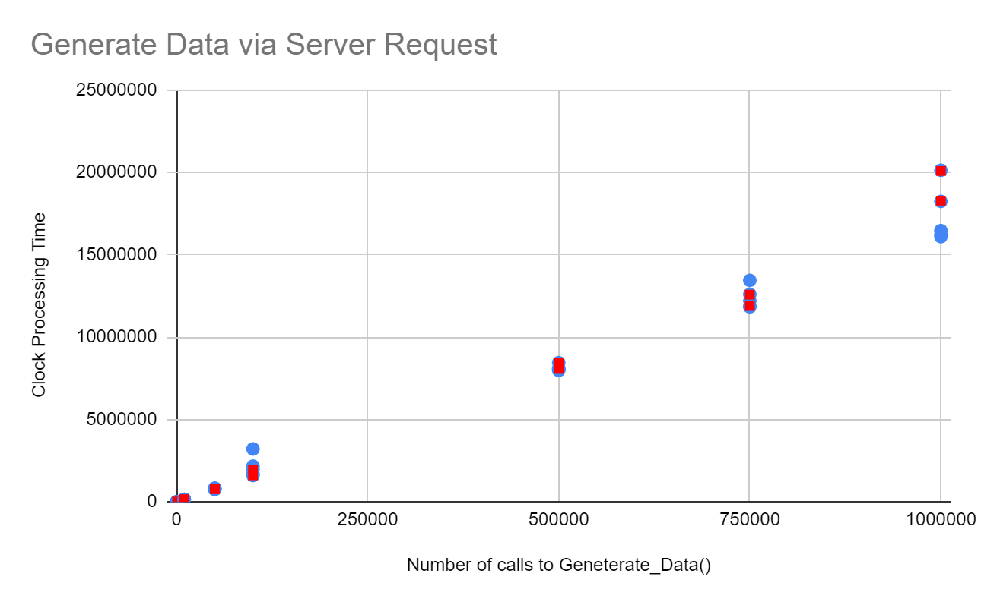

In the first graph shown, the data was collected from calling the Generate_Data() function through a request to a server. On the x-axis, the number of calls to Generate_Data() per test are shown, and on the y-axis, the clock processing time for each test is shown. The Blue data points on the graph correlate to each test, for example 500000 iterations of Generate_Data() correlate to <10000000 clock ticks. There were many tests run for each x-value, to insure the data collected could be as accurate as could be. The red data points are a 95% confidence interval for each number of calls to Generate_Data().

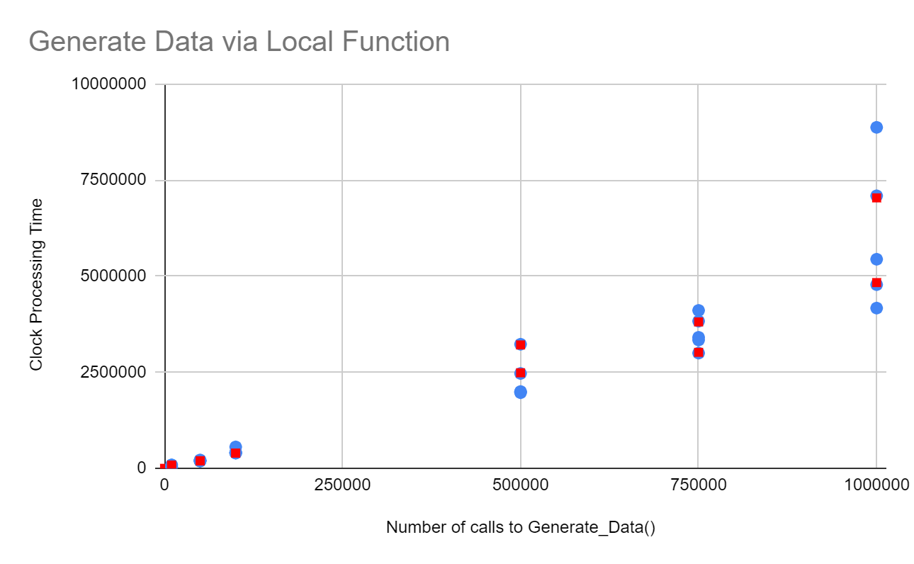

In the second graph shown, the data was generated by calling the Generate_Data() function within a local function. The x-axis displays the number of calls to Generate_Data() per test, while the y-axis shows the clock time for each test. The blue data points correlate to the number of clock ticks per number of calls to Generate_Data() for each test. The red data points are a 95% confidence interval for each number of calls to Generate_Data().

As you can see between the two graphs, there was a marginal increase in the time it took to generate the same amount of data through the server, compared to the local function calls. I took multiple measurements per number of Generate_Data() calls, to ensure the best results. All of my measurements were taken Sunday night on campus, to ensure the fastest connection to the Linux compute server. Alternate results could have been recorded depending on the time of the experiment, and the load on the Linux compute server.